 Trader Oracle Guidelines

1. To check out the reports on the oracle application click on the report link as shown in the image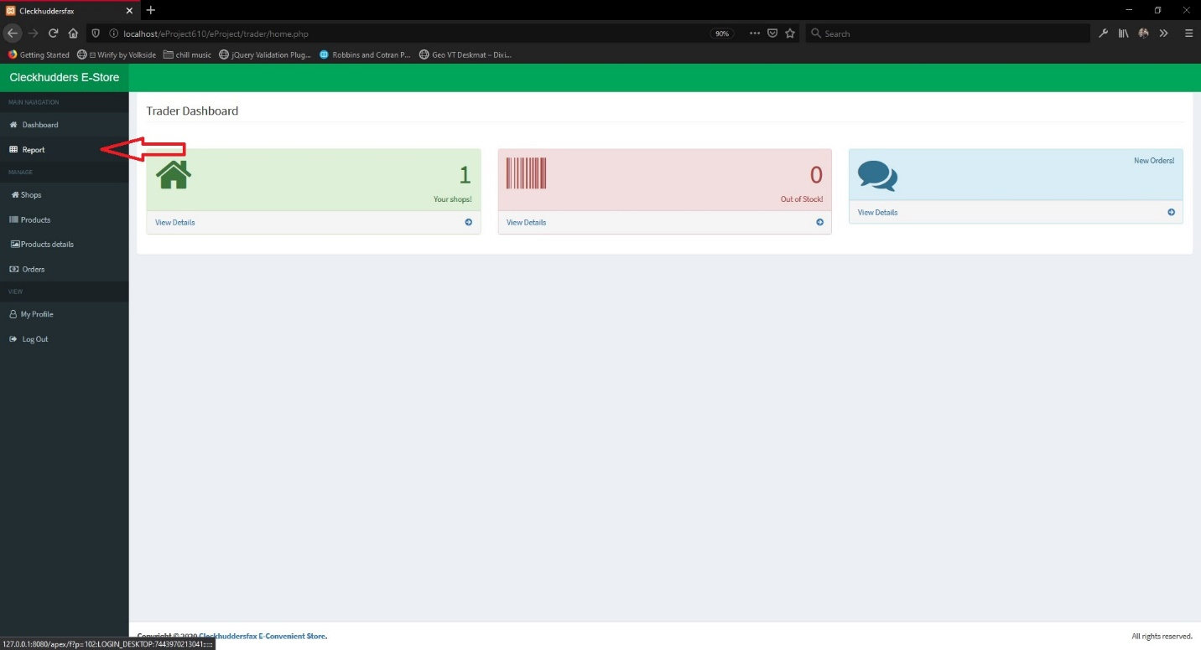
2. You will be redirected to the apex application as shown in the figure fill un the login information entered in step 6 and click login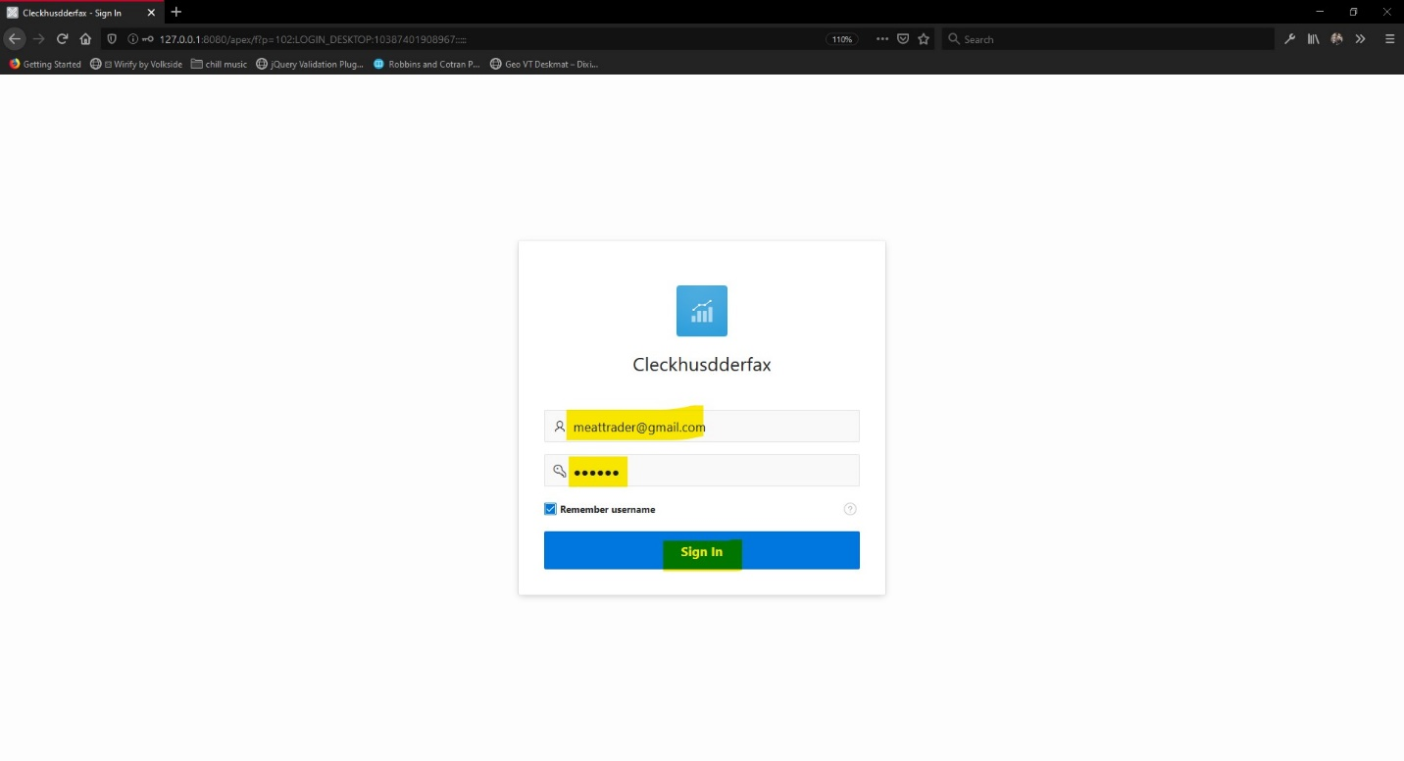
3. After you login you can access variety of reports as shown in the images below  
   Dashboard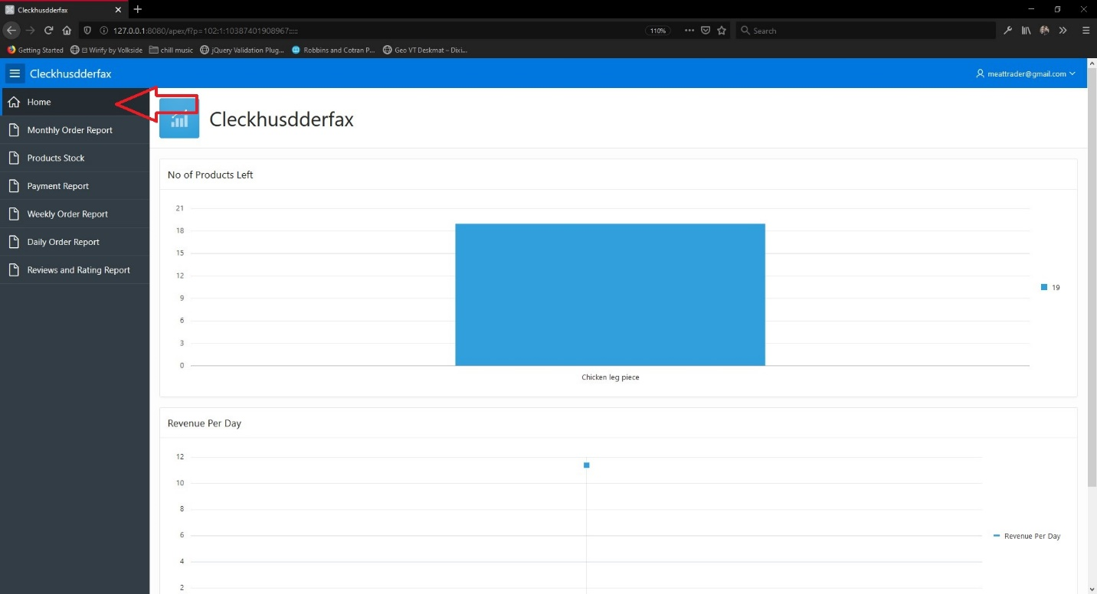

Product Stock Report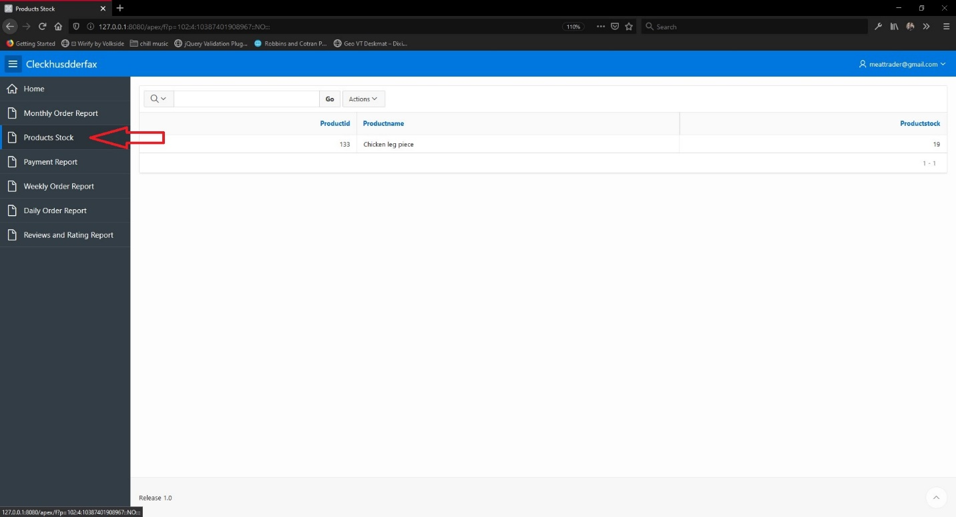

Payment Report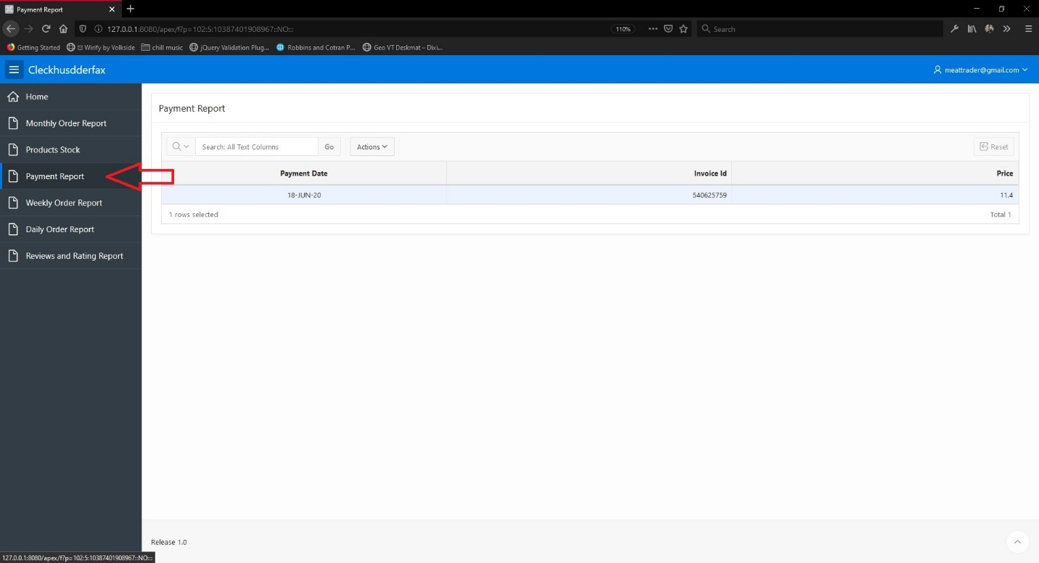

Review and Rating Report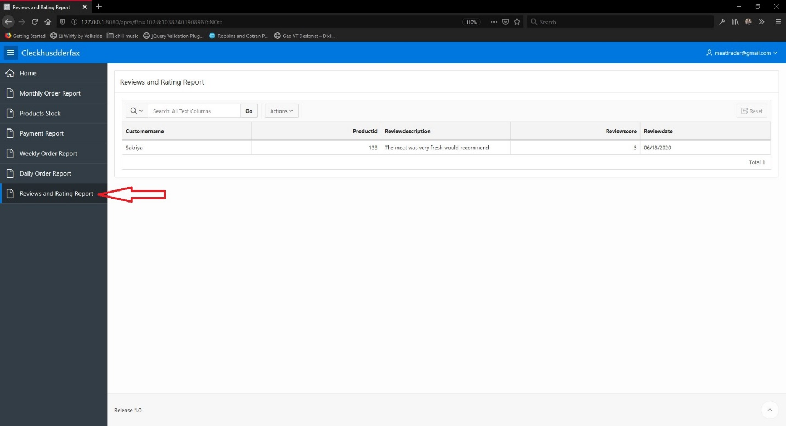

Daily Order Report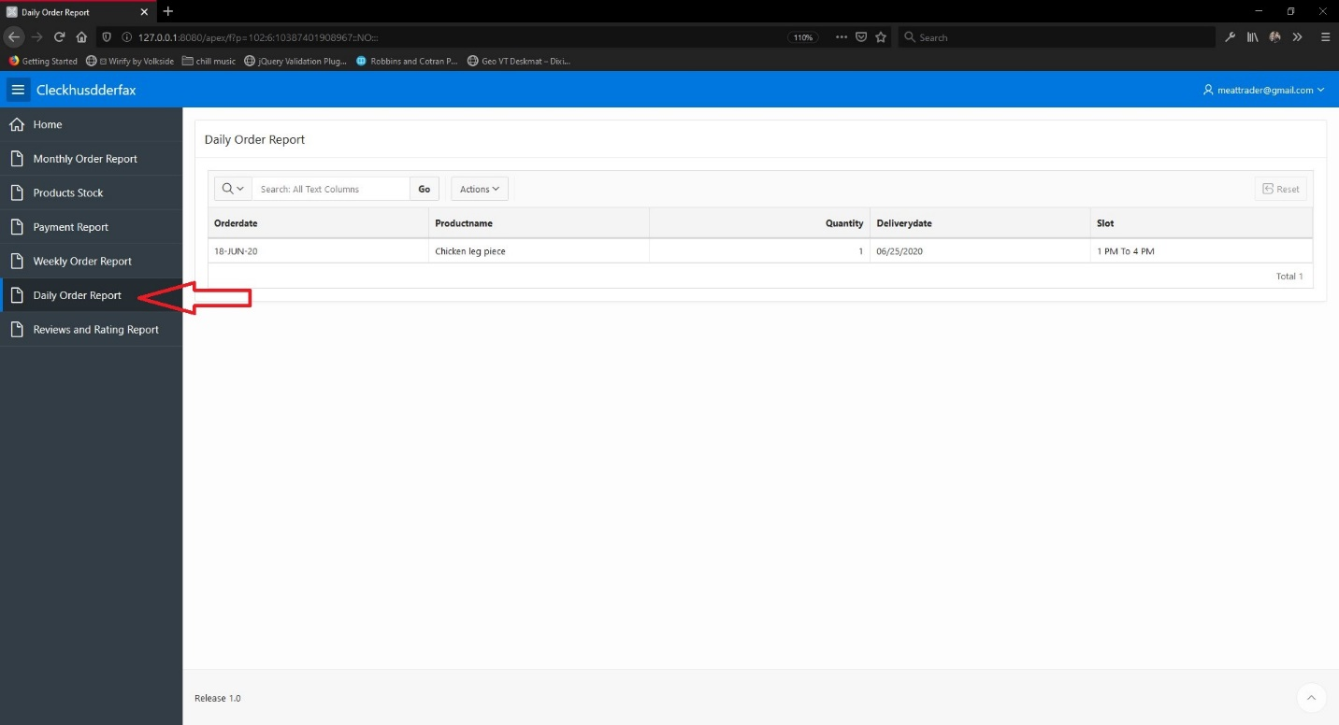

Weekly Order Report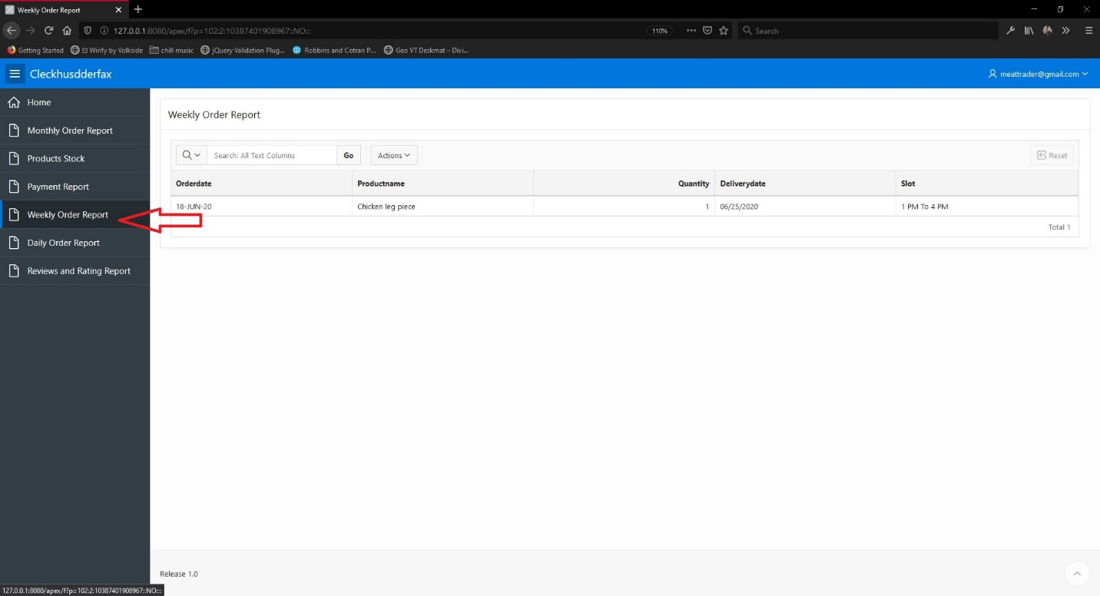

Monthly Order Report